**Bi-Weekly Report of (Team# 10 ) Week # 8**

<All teams will report their progress on Friday Starting from Week 6 (2024.04.12) >

**What were the goals for the last 2 weeks?**

< Enumerate your goals for the last 2 week. Be sure that your team goals are measurable and connected to your requirements. > Each member of the team should mention his goals individually.

* Learning UE5

1. **[All members]:** Continue learning UE5 with lectures and tutorials. ex) casting & actor attachment, adding and removing tags, Tarray,

* Basic Network Environment Settings (barebone)
* **[Yiel Jang]:** Implement a barebone network multiplayer environment where users can access a single world in the remote game server.
* Modular level layout Design -> World design
* **[Jongeun Park]**: Make a rough sketch of a world concept with a modular level design method.
* Polish MiniGame B(Pixel puzzle game) Flow & Mechanism
* **[Minseop Lee + others]:** Finalize mechanisms & gameplay flow of MiniGame B. A flow must be sophisticated enough to implement in a code. Should decide how to approach the z-axis variance of cube size when players are moving around.
* Design UI & outlining Sound design.
* **[All members]:** Will be discussed in a separate group meeting session.

**What goals were accomplished this week?**

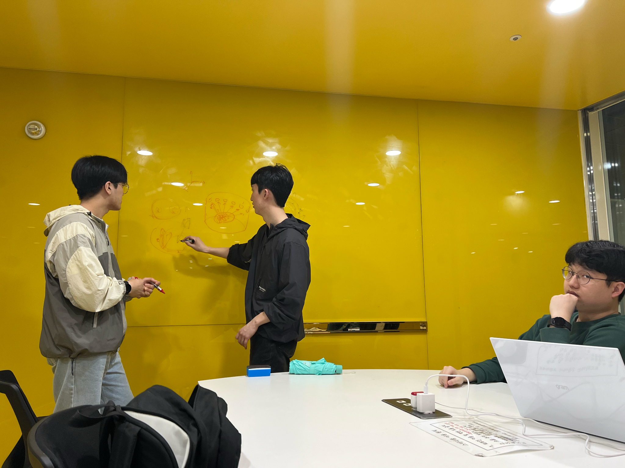

<discussion>

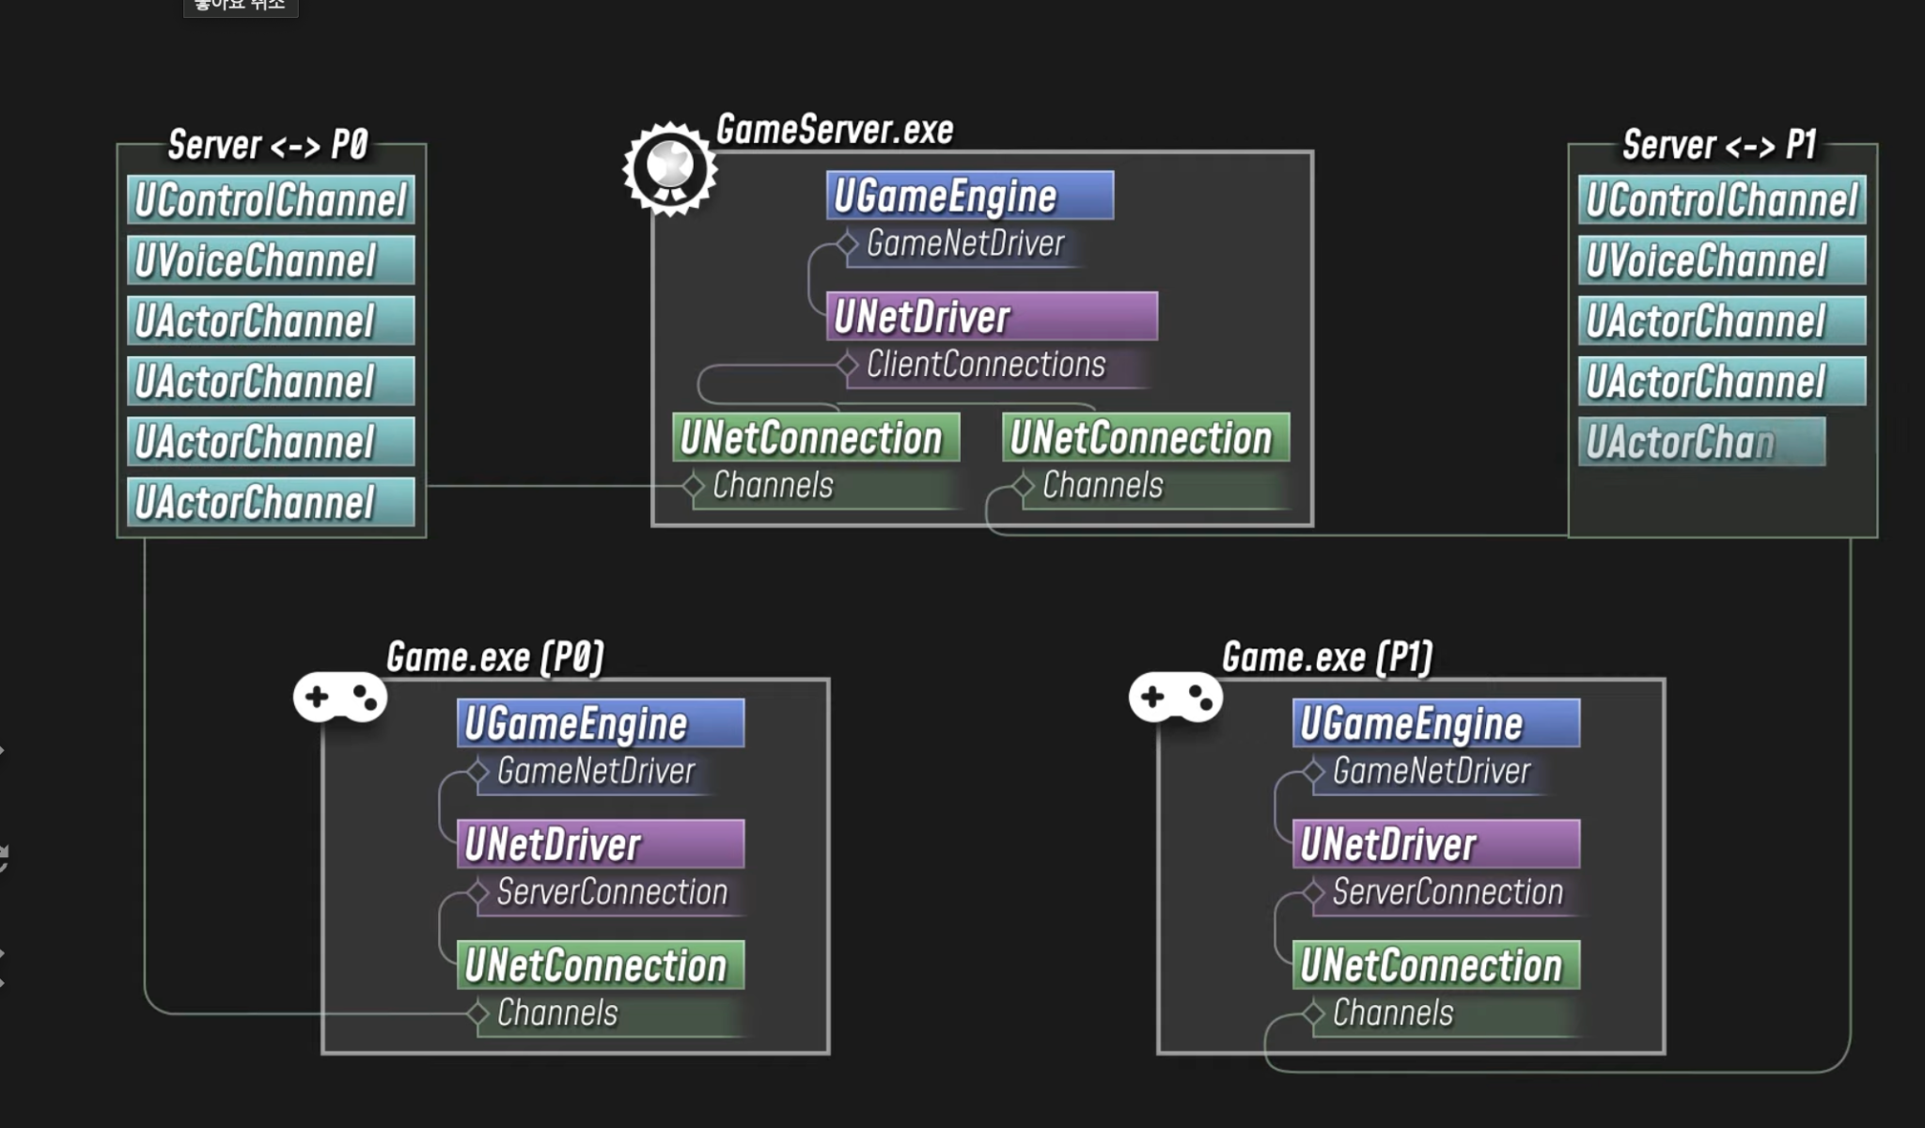

<Network organization of our game>

* (WIP) Network Environment
  + Works on local machine – need to fully test it on next week
    - Replication System
    - On Local Machines (later will be pushed to AWS or other cloud services)
* World Design
  + Designed the world using paid assets
  + Modular design for efficiency
* MiniGame B Flow & Mechanism
  + Colosseum shaped map
  + Discussion on how to implement cube shape variance in 3D space
    - Get FOV value from the camera and adjust with it
    - (If possible) Use shaders – modify rendering pipeline to make cube 3D view correction
  + Gameplay flow
* UI & Sound design
  + On relatively low priorities
  + Minimalistic clean UI for implementation
  + Cartoonish Sounds for basic interactions

**Reflect critically on any goals not accomplished.**

< Explain why you did not complete any missed goals and what you plan to do moving forward with respect to these goals. > Each member of the team should mention his goals individually.

Each member of the team should mention his goals individually.

* (WIP) Network Environment:
  + Link team members by using Perforce: Unfortunately, we didn't manage to integrate Perforce into our workflow as intended. Some members can’t change code or accept changes of code although they are linked by perforce. This was mainly due to the learning curve associated with Perforce and some technical difficulties we encountered during the setup process.

To address this, we will dedicate more time to learning and troubleshooting Perforce, with the aim of successfully implementing it into our workflow in the coming weeks.

**What are the goals for next two weeks?**

< Enumerate your team goals for next 2 week. Be sure that your goals are measurable and connected to your requirements. > Each member of the team should mention his goals individually.

1. Complete Testing of the Network Synchronization System

- Goal: We need to ensure all networked components are perfectly synchronized without errors.

- Approach:

- Identify Scenarios: Pin down every critical scenario for network synchronization, including the unusual edge cases.

2. Refine the Level Design

- Game Building: Enhance architectural elements, textures, and interactivity.

- Ready Room: Make the waiting area more engaging and user-friendly.

- In-Game Table: Ensure the design supports smooth gameplay and looks great.

- End Session: Craft a clear and memorable conclusion to the game sessions.

3. Implement the Core Card Game Mechanics

- Steps:

- Define Rules: Document all the game rules and mechanics clearly.

- Algorithm Development: Code algorithms for shuffling, dealing, scoring, and enforcing rules.

- Integration Tests: Check that the card engine integrates smoothly with the overall game system.

- User Testing: Run game sessions to collect feedback and tweak the mechanics as needed.

4. Design the Card Assets and Architecture

- Steps:

- Asset Creation: Design both sides of the cards, including the artwork and text.

- Structure the Data: Total 57 number of cards, each card has 8 different 3D symbols.

- Dynamic Loading: Work on efficient loading and unloading of card assets during gameplay.

5. System-Wide Testing

- Goal: Perform extensive testing to make sure every component of the game works well together.

- Steps:

- Integration Tests: Focus on how different parts like the card mechanics and network systems work as a unit.

- Stress Tests: Simulate high traffic to understand the system’s limits.

- Usability Tests: Get real users involved to test the game interface and overall user experience.

- Resolve Issues: Address any problems found during testing promptly to stabilize the release.

**How many hours were spent on each goal noted above?**

< For each person on the team list the goals they worked on including completed and non-completed goals

<That means each member should mention what exactly he have done to accomplish the goals of this week>

* Learning UE5
  1. Learning Toon Tanks section(6hr)
  2. Learning Creating a Multiplayer Plugin section (3hr)
* (WIP) Network Environment
  1. Building basic network environment on local machine (3hr)
* World Design
  1. Designing world and determining assets (3hr)
* MiniGame B Flow & Mechanism
  1. Deciding the game progress and rule (3hr)
  2. Designing the game and concept (1hr)
* UI & Sound design
  1. Deciding the concept and assets(2hr)